Pit Station User Manual

Siyuan Wang

05/11/13

Contents

Connections: 3

Power Supply Control 3

How to plot Cell Characteristics: 3

Software Manual 3

Fig. 1. Main Screen 4

Fig. 2.1 Toolbar: File 5

Fig. 2.2 Toolbar: Configurations 5

Fig. 2.2.1 Configurations: Set Parameters 6

Fig. 2.2.2 Configurations: Advanced Configurations 6

Fig. 2.2.3 Toolbar: Configurations: Manual Update 6

Fig. 2.3.1 Mode: Data Collection 7

Fig. 2.3.2 Mode: Charging Mode 8

Fig. 2.4.1 Tools: Set Bypass Switches 9

Fig. 3. Charging Parameters Confirm 10

Fig. 4. Charging Parameters Setup 10

Fig. 5. Charging Parameters Save to File 11

Fig. 6. Charging Parameters Load from File 12

Fig. 7. Charging Monitor Window(while Charging) 12

Charging State Transition Diagram 14

# Connections:

* The laptop can be connected to the Pit Station Box at the front via a male-to-male USB cable
* The back of the Pit Station Box requires
  + An I2C cable from the Pack
  + A 10 AWG power cable from Pack, plugged into the Anderson connector.

# Power Supply Control

* Turn on “Charger” in the power hub
* Turn on the power supply with the switch on the left hand side
* Make sure the green LED above “out” is off. If it is on, click “out” to make it turn off
* Press “prev” and adjust the current to be 20/25 or whatever charging current you are using. Now adjust the voltage to be 12 voltages

# How to plot Cell Characteristics:

* What you get in your directory above your dist folder are the following files:
  + ChargingCharacteristics.txt
  + EventLog.txt
  + DatabaseLog.xml
* Open the Charging Characteristics.txt in Excel
* Delete corrupted lines by inspection
* Insert two rows on the left
* Copy the first cell in the system time column and copy it to the cell that is to the left of it
* Copy that value for all the cells in that column
* Having the first column being the result of the third column value subtracted by the second column value(this is getting the relative system time based on the initial start time) and divided the result by 60(converting seconds to minutes).
* Plot this column against the voltage columns to get the cell characteristics graphs.

# 

# Software Manual

1. Make sure you place the dist folder on the desktop and having a shortcut linking to the jar file. Put the shortcut inside the “Startup” folder so that it will start the program when the computer is turned on.
2. Double click the Charger.exe to run the cell charging program
3. After a brief period, this “Charging Monitor” screen will be displayed as shown below.

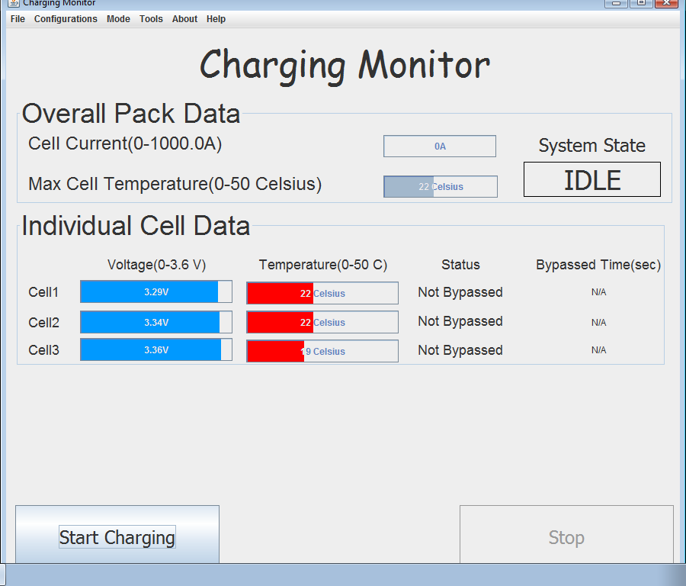

## Fig. 1. Main Screen

* On this screen, the user may monitor the overall pack information as well as the individual cell information as long as this program is running.
* An Introduction to the Toolbar:
  + File:
    - To quit the program, click on “Quit” and wait for 15 seconds.

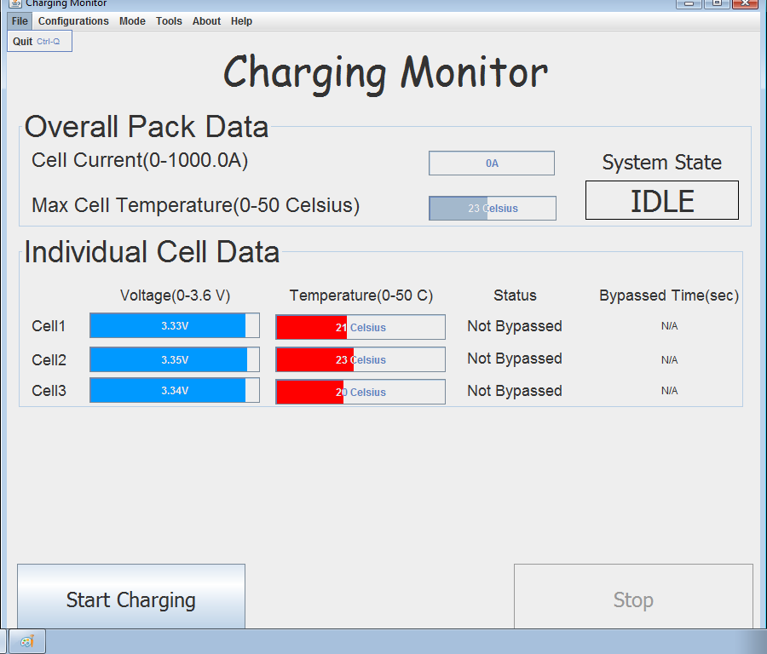

## Fig. 2.1 Toolbar: File

* + Configurations

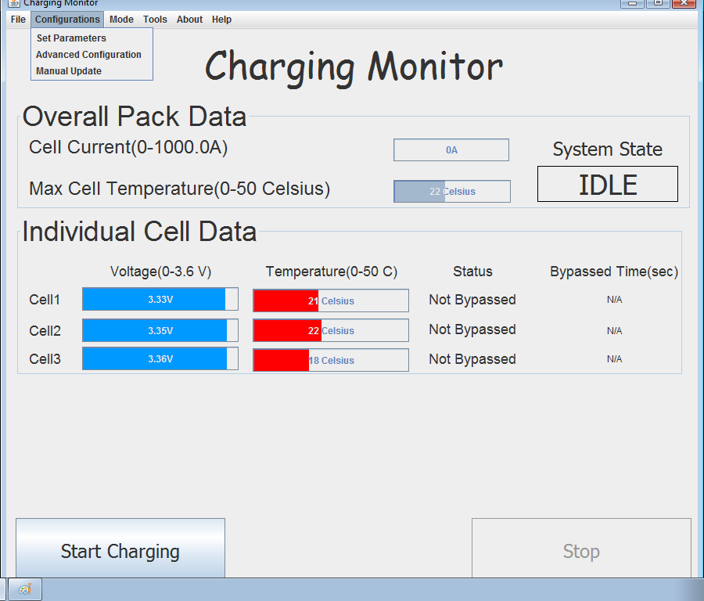

## Fig. 2.2 Toolbar: Configurations

* + - Set Parameters: You can set the charging parameters from here. The acceptable range for each parameter is indicated on the right.

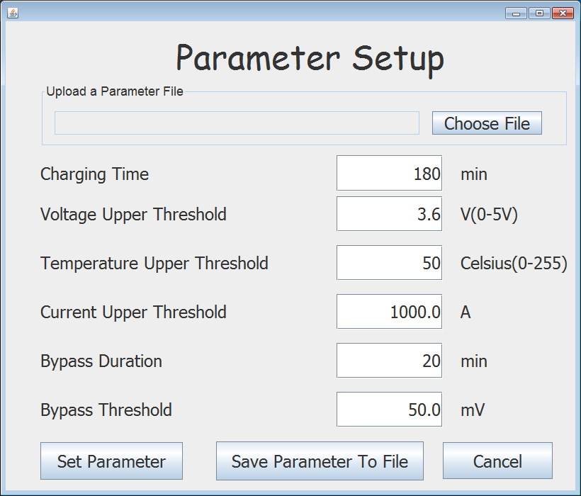

### Fig. 2.2.1 Configurations: Set Parameters

* + - Advanced Configuration:
      * You are allowed to configure Voltage, Current, Temperature calibration offsets here
      * You can also set the bypass cutoff, which will affect the cell-balancing algorithm.
      * Click on “Update Offsets” to actually set the new set of values

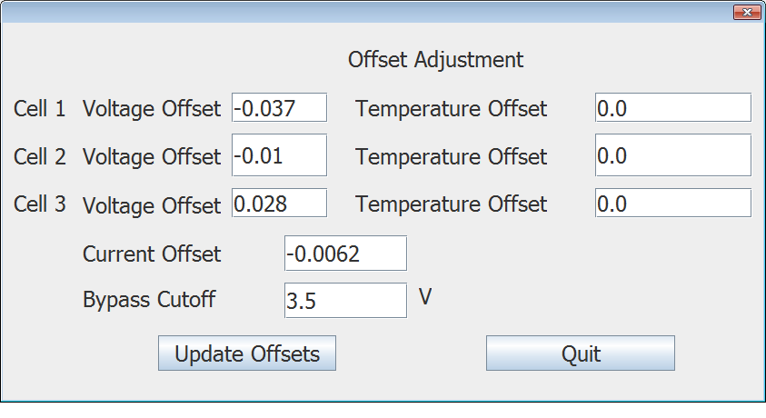

### Fig. 2.2.2 Configurations: Advanced Configurations

* + - Manual Update:
      * You can manually set the voltage/temperature/current values. Please only change these values if you have selected “Manual Mode” under “Mode” ->”Data Collection”.
      * Click on “Click to Update” to actually update the values.

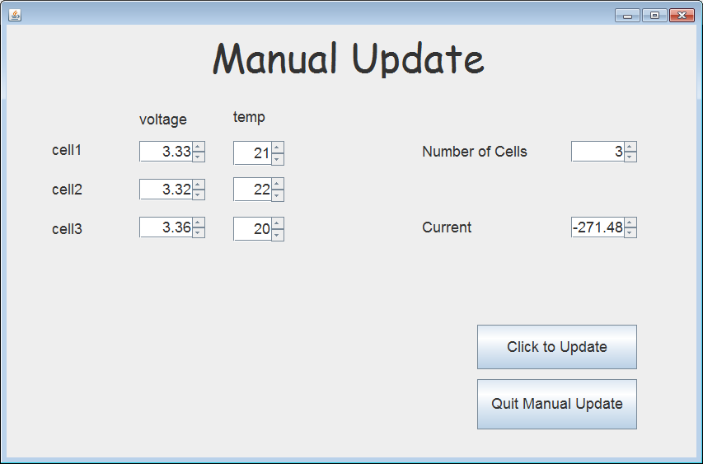

### Fig. 2.2.3 Toolbar: Configurations: Manual Update

* + Mode:
    - Data Collection:
      * Automatic Mode allows you to constantly checking for BMS connection. If BMS is disconnected, warning will be prompted to the user and charging will be shutting down if it has started. This is the default mode.
      * Manual Mode allows you to run the software without the BMS connected. You can use “Manual Update” under “Configuration” Menu. This mode is used to test charging algorithm as well as some other functionalities.

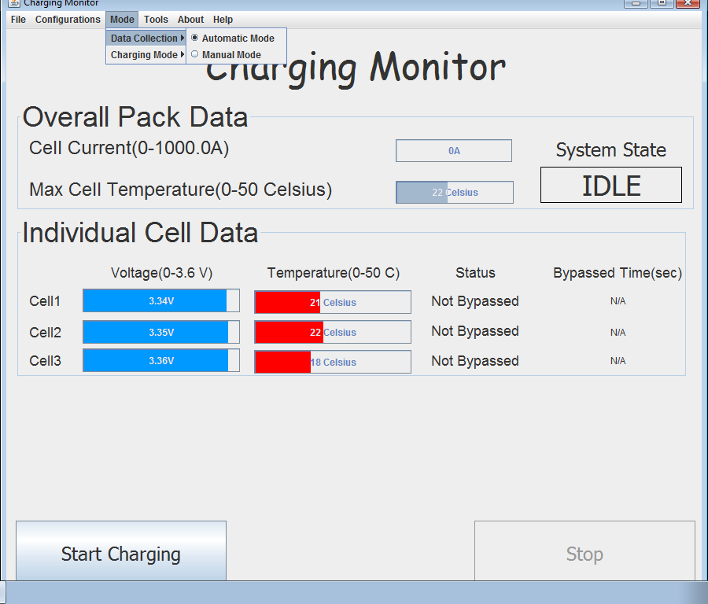

### Fig. 2.3.1 Mode: Data Collection

* + - Charging Mode:
      * With Arduino Board indicates that it will constantly ping the Arduino board to check if it is still there to make sure that if I do need to turn on/off the relay, I will be able to do so. The program is default with Without Arduino Board mode, but will switch to With Arduino Board if it detects Arduino on Start-up or user set it to With Arduino Board.
      * Without Arduino Board indicates that it will monitor charging without controlling the Arduino Board(Relay).

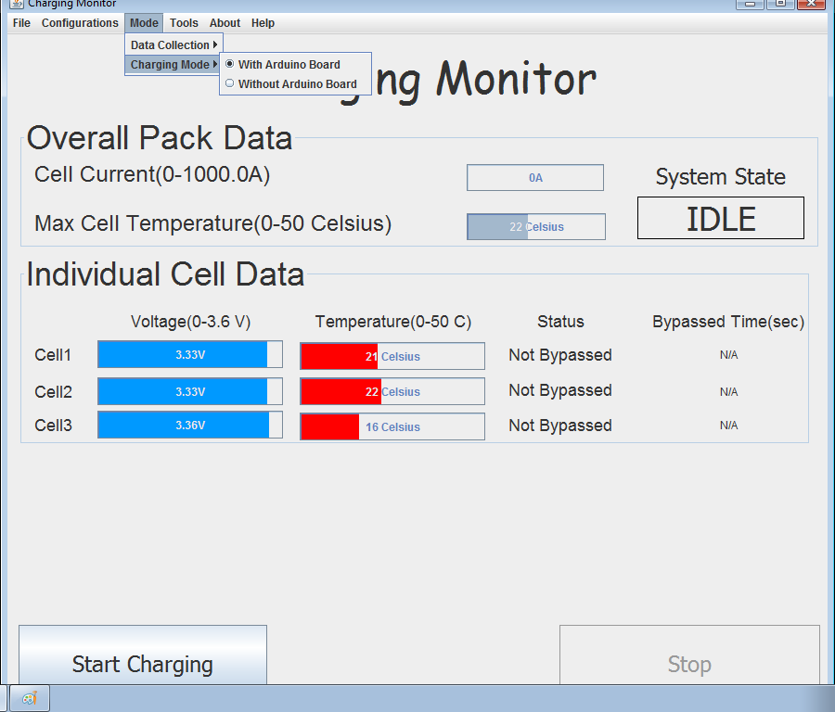

### Fig. 2.3.2 Mode: Charging Mode

* + Tools:
    - BMS Port Name:
      * This will print the name of the COMM port that is connected to the BMS board(I2C adaptor)
    - Arduino Port Name:
      * This will print the name of the COMM port that is connected to the Arduino board
    - Set Bypass Switch on the BMS with Address:
      * You can hover over different board addresses and turn the bypass switch on the corresponding BMS board to be on/off.

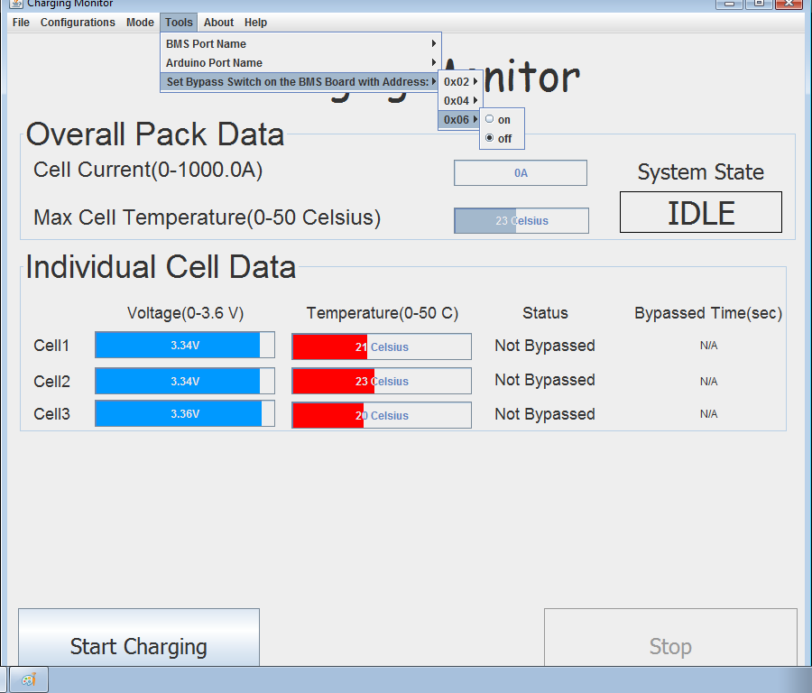

### Fig. 2.4.1 Tools: Set Bypass Switches

* + About & Help:
    - These two toolbar menu give you some general information about the software, the senior design team and the source code documentation.
* Aside from the menu bar, there are two buttons at the bottom. One is “Start Charging” and the other is “Stop”. The Stop button is initially faded and not clickable (that’s okay, you didn’t break it!), so the user may only click on the “Start Charging” button to start the charging process. Instructions about the menu bar will be explained later.

1. Once “Start Charging” is pressed, the window shown below will be displayed on the screen.

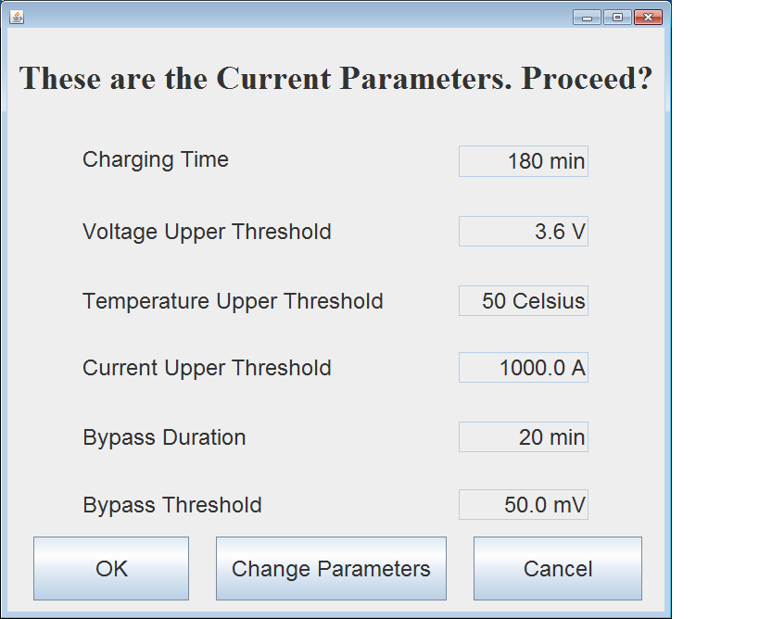

## Fig. 3. Charging Parameters Confirm

* This will confirm the information about cell balancing algorithm parameters with the user. The values displayed are the based on the most recent parameter setup or the default values if the user has never set up parameters before.
* If the user agrees with these parameters, click “OK” button to start charging.
* If the user wants to change any of the parameters, please press the “Change Parameters” button to navigate to the *Parameter Setup* page.

1. If the user clicked on “Change Parameters” in the window shown in Fig. 2, the user should be prompted with the following page:



## Fig. 4. Charging Parameters Setup

* Enter the desired parameter values for charging, then press “Set Parameter” button to finish the parameter setup process.
* If you are using one set of parameters often, it is probably a good idea to save all the parameter values to a local file so that you can easily load it back without having to type each one individually. Once you click on “Save Parameter To File” button, the following window should be displayed:

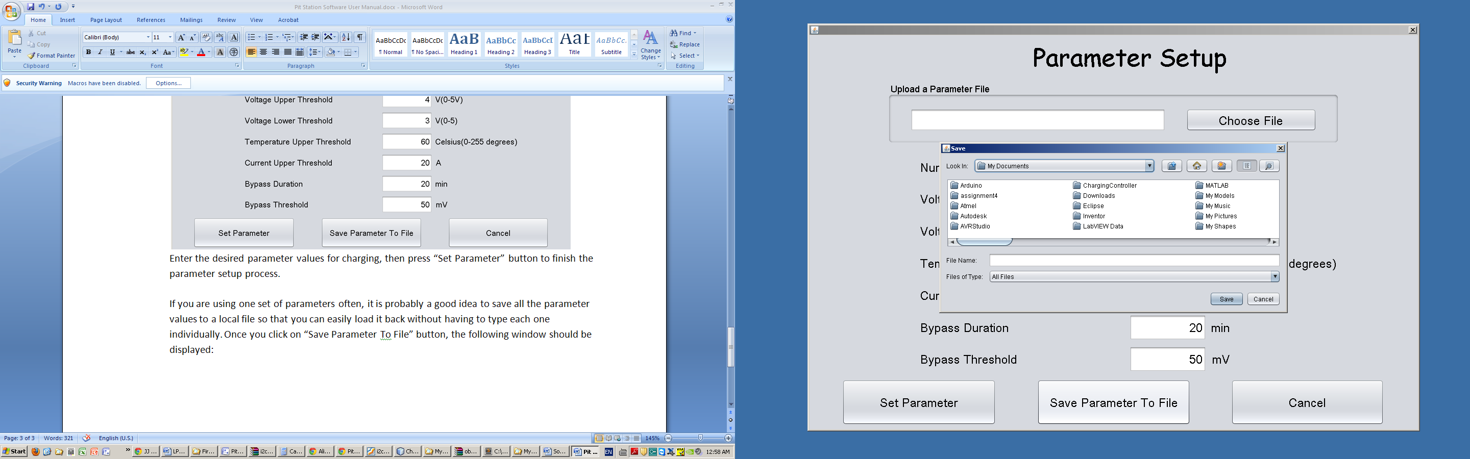

## Fig. 5. Charging Parameters Save to File

* Type the desired name for the local file. If you don’t type an extension, it will save it as a *.txt* file.
* If you click on the “Choose File” button in the *Upload a Parameter File* panel, the user will be prompted with the following window to select a parameter file.

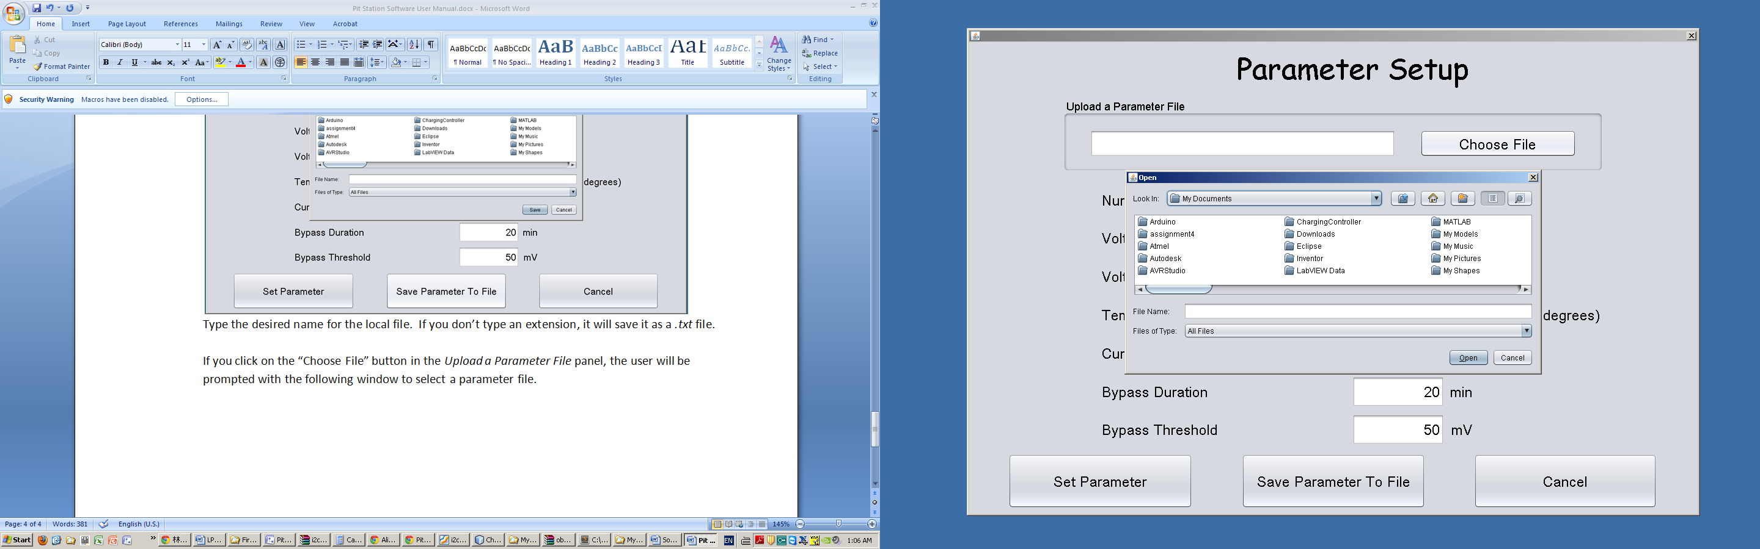

## Fig. 6. Charging Parameters Load from File

* Select previously saved parameter files so that all the saved parameters will be automatically loaded into the corresponding fields showed in Fig. 3.

1. If the user click on the “OK” button in Parameter Confirm Window(Fig.2) or the “Set Parameter” button in Parameter Setup Window(Fig. 3), the user will be guided back to the charging monitor window(shown below).

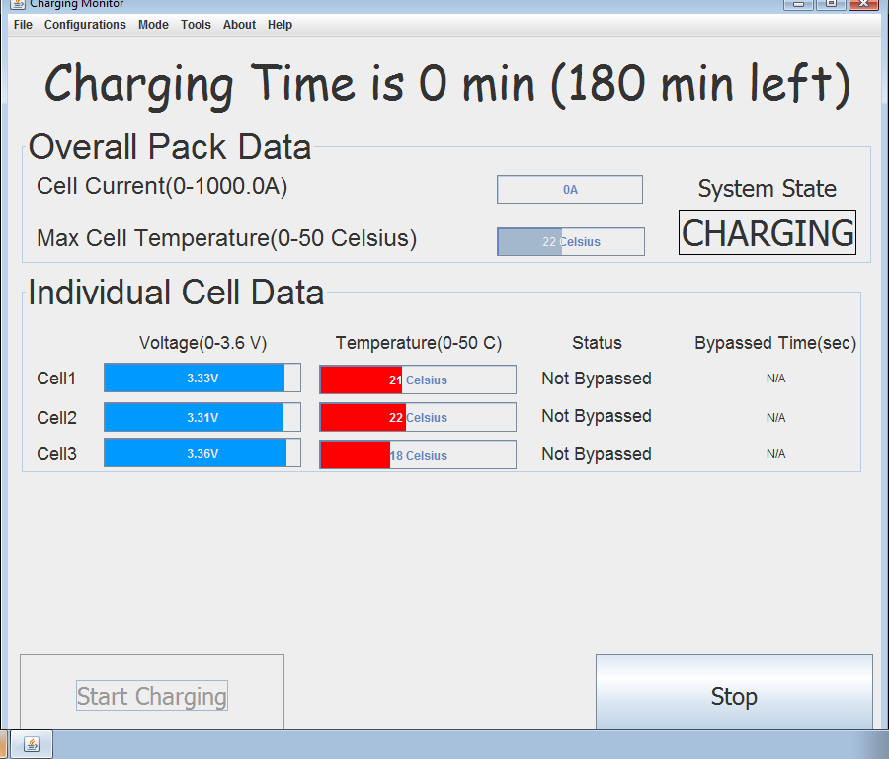

## Fig. 7. Charging Monitor Window(while Charging)

* The Stop Button now becomes available to click while the “Start Charging” button is no longer clickable.
* The System State becomes “CHARGING” if none of the cells exceeded the current, voltage and temperature threshold initially (Otherwise a warning message will be displayed and charging would not be started).
* Once the charging of the pack is finished, the system state will be updated to “DONE”. In this case, charging is automatically stopped; “Stop” button will also become non-clickable.
* Once the voltage, temperature and current values are all within the acceptable range, the “Start Charging” button will become available to click again and the system state will become “IDLE”.
* If the user press “Stop” button before the charging process is finished, then the System state will become “IDLE” and the “Start Charging” button will become available to click again.
* To illustrate what “System State” is, the following state transition diagram is attached.

# Charging State Transition Diagram

